Assignment
1) Use if-else to find the greatest of three numbers.
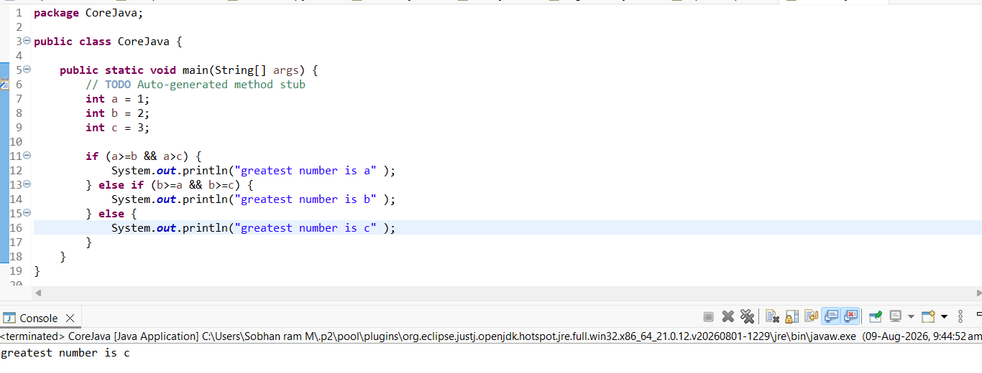
2) Implement a calculator using switch statement.

